Rotary Club of Conifer Foundation
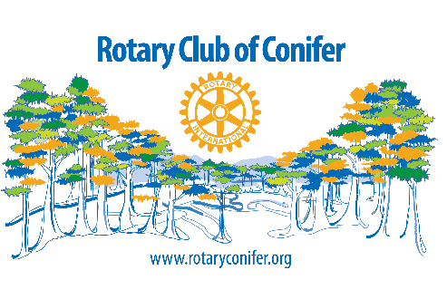

Grant Application

Application Deadline: Sept. 8, 2017
____________________________________________________________

Program Area:

___ Arts & Culture ___ Children, Youth & Families
___ Vocational ___ Community Services

Type of Support Requested:

___ Event Sponsorship ___ Funding a Specific Program
___ General Operations ___ Capital

Amount of Request: _________ Total Current Operating Budget: __________

Organization Information:

Name of Organization: ______________________________ Tax ID# __________

Street Address: ____________________________________________

City: __________________________ County: _____________________

State: ________________________ ZIP: ________________________

Telephone: ____________________ Fax: ________________________

E-Mail: ___________________________ Web site: ____________________

Number of full-time employees (Combine part-time employees so that 40 hours/week equals one full-time employee): ________

Name of Primary Contact: __________________ Title: _______________________

If Applicable:

Name of Project or Event: ______________________________________________

Total Project / Event Expenses: __________________________________________

Date(s) of Event (or start of project): _____________________________________

Please answer the following questions, use additional pages if needed:

- What is your mission statement?

- What need(s) will you be fulfilling in the community as a result of this grant?

- Describe the event or program for which you are requesting funds.

- How many people do you expect to attend your event (if applicable)?

- How many people will be directly served by your organization this year?
  - If the funding request is for a specific program, how many people will be directly served by it?

- What are the measurable outcomes (results) that you expect your programming or events will have on those being served?
  - Who will benefit from your work?
  - What specific change in condition or behavior will they experience?
  - How long will it take to see benefit from this program and how long do you expect this benefit to last?
  - How will you measure and evaluate the change and the program’s overall effectiveness?

- What portion of the funds requested will be applied directly to the program or event?

- What donor recognition will the Rotary Club of Conifer Foundation receive if this grant request is approved?

Signature of Applicant: _________________________________________________

Title: ____________________________________ Date: _________________

Continued on next page
Required Attachments:

- Current operating budget including income and expenses. (If less than 90 days remain in your current operating budget, please submit the proposed budget for the next fiscal year.)

- Most recent year-end financial statement.

- If applicable, the event or program budget including expected income and expenses.

- If applicable, event or program sponsorship levels.

- List of your board of directors and their occupations / community affiliations.

- IRS 501(c) (3) determination letter.

- Repeat grant requests must include their final report (or interim report if a multi-year project) including narrative, financial summary, and donor recognition for the most recent grant, if not already submitted.

Submit Completed Application and Supporting Material to:

Rotary Club of Conifer
PO Box 1430
Conifer, CO 80433
ATTN: Wendy Woodland

Electronic Applications to:
RotaryClub@RotaryConifer.org

______________________________For Rotary Use Only ______________________________

Approved / Denied / Countered: __________________________________________________________

Rotary Club of Conifer Foundation President: _____________________________ Date: ______________

